**What is a PIR Sensor?**

A PIR (Passive Infrared) sensor is an electronic device that detects motion by sensing infrared radiation (heat) from objects in its environment. It's called "passive" because it doesn't emit any energy; it simply detects the IR radiation emitted by surrounding objects, especially humans and animals.

**How Does the PIR Sensor Work?**

* Every warm object emits infrared radiation.
* The PIR sensor has two infrared-sensitive slots made of pyroelectric material.
* When there's no movement, both slots detect the same amount of IR radiation.
* When a warm object (like a human) moves across the sensor’s field of view, it causes a difference in the IR levels between the two slots.
* This difference is converted into a voltage signal that can be read by a microcontroller or trigger a circuit.
* Most modules (like the HC-SR501) also have a built-in amplifier, comparator, and logic circuit that outputs a digital HIGH or LOW signal.

**How to Use a PIR Sensor with Arduino**

**Components Needed:**

* Arduino board (e.g., Uno, Nano)
* PIR sensor (e.g., HC-SR501)
* Jumper wires
* Breadboard (optional)
* LED or buzzer (for testing)

**Connections:**

| **PIR Sensor Pin** | **Arduino Pin** |
| --- | --- |
| VCC | 5V |
| GND | GND |
| OUT | Digital pin (e.g., D2) |

This circuit is a simple motion detection setup using a PIR sensor, an LED, and an Arduino Uno. It's built on a breadboard, where the PIR sensor detects motion and triggers the LED to turn on when motion is sensed.

The PIR sensor has three pins—VCC, OUT, and GND. VCC is connected to the 5V pin on the Arduino, and GND goes to the Arduino's GND. The OUT pin is connected to digital pin 2 on the Arduino. This pin sends a HIGH signal when motion is detected.

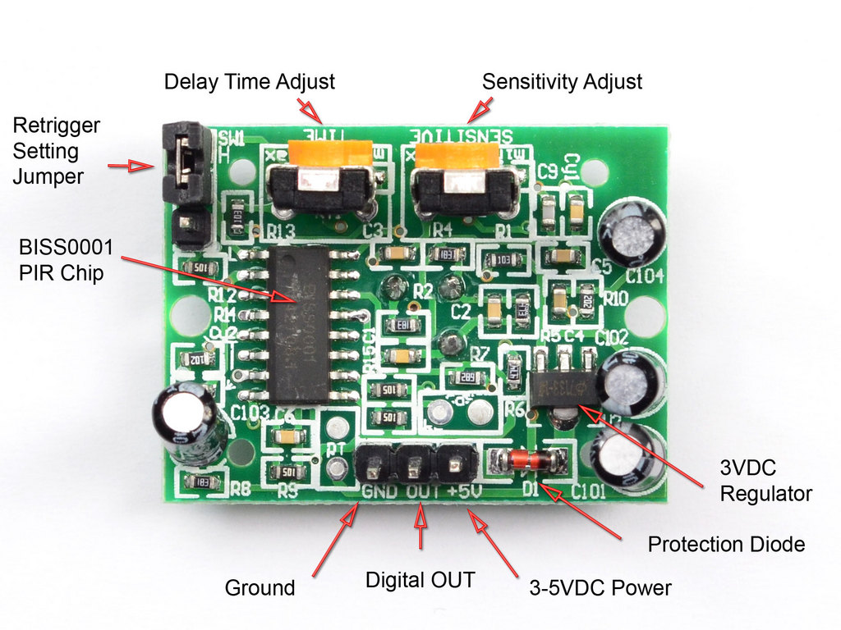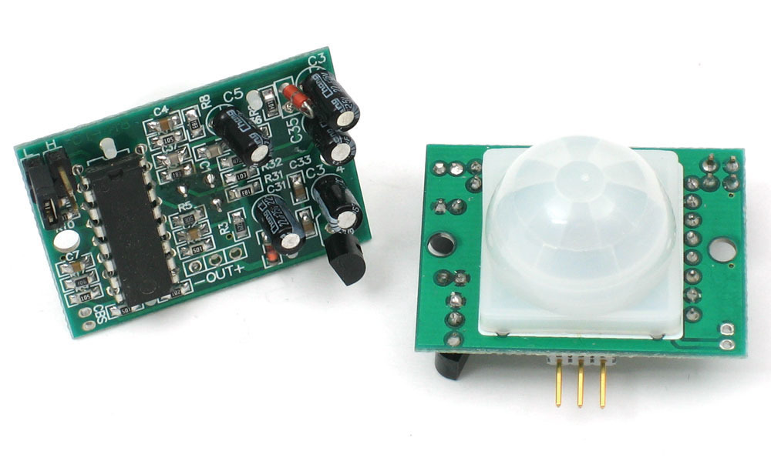

The LED is used as an output indicator. One leg of the LED (the longer leg, anode) is connected to digital pin 13 through a current-limiting resistor. The other leg (cathode) is connected to GND. When the PIR sensor detects motion and sends a HIGH signal to pin 2, the Arduino reads this and turns on pin 13, lighting up the LED.

On the breadboard, the power lines (red and blue) are used for distributing 5V and GND. The sensor and LED are both powered from these rails. The resistor in front of the LED is there to prevent it from drawing too much current and burning out.

In summary, when a person or warm object moves in front of the PIR sensor, the sensor sends a signal to the Arduino. The Arduino then turns on the LED as a response. Once no motion is detected, the signal goes LOW and the LED turns off.